**MECH 550**

**Project 3**

Peiguang Wang, Sichao Zhang

*1. A succinct statement of the problem that you solved.*

1) We implement core codes of random tree planner based on the algorithm of RRT.

2) We build two different environments (called Fence and Maze). In these two environments, we test point robot and square robot to see their performances, and the process is visualized.

3) Then we use benchmarking to compare several other planners with RTP in computation time, path length, number of states and so on. From the figures obtained, we observe the differences and make the conclusion.

*2. A short description of the robots (their geometry) and configuration spaces you tested in*

*exercise 2.*

1) The point robot. A point has two parameters, its x-axis coordinate(x) and y-axis coordinate(y). x and y defines its location in the workspace. Its configuration space is the workspace but except the obstacles.

2) The square robot. A square has four parameters, the x-axis(x) and y-axis(y) coordinates of its center, the length of its edge Side Length and the rotation angle θ with respect to its center. x and y defines its location in the workspace, Side Length defines its size and θ defines its rotation state. Configuration space for a square robot is a 3 dimension spaces, since it has 3 DOFs (x, y, θ).

*3. Images of your environments and a description of the start-goal queries you tested in*

*exercise 2.*

We build two different environments. One is called fence, and the other is called maze.

Environment 1 (Fence):

Figure 1 shows the first environment fence.

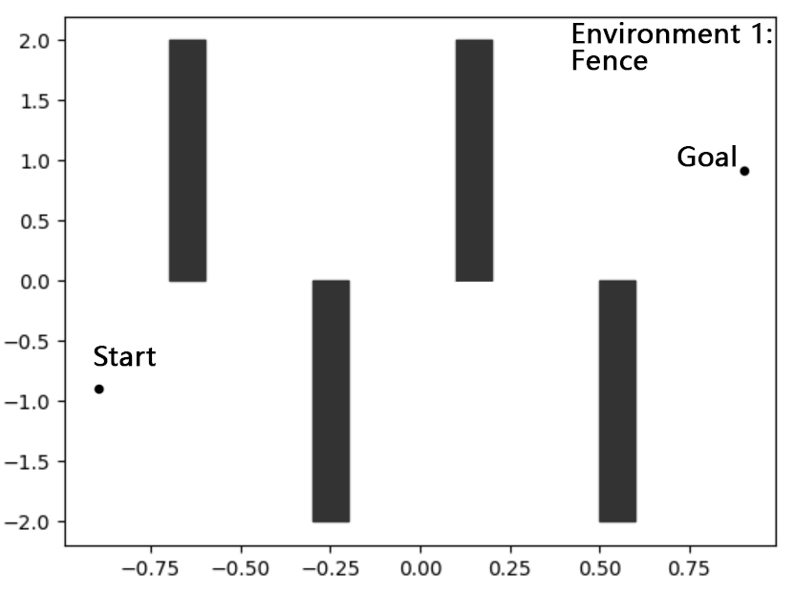

*Figure 1. Environment 1 Fence*

The coordinate of the start point is (-0.9,-0.9), and the goal point is (0.9,0.9).

Environment 2 (Maze):

The second environment we create is called maze, as is shown in Figure 2.

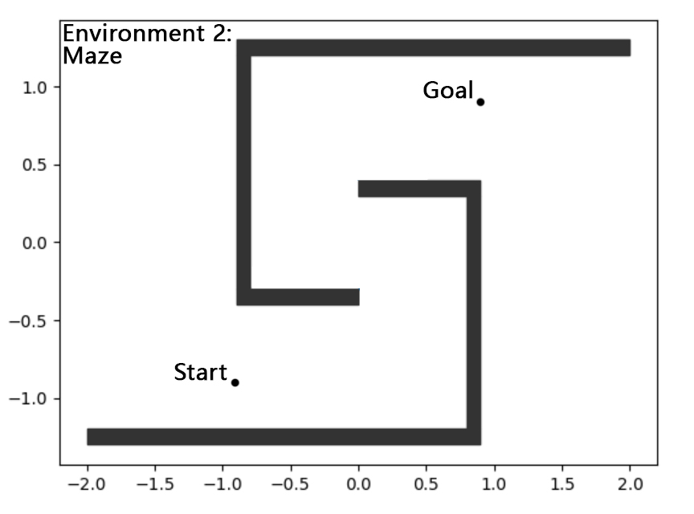

*Figure 2. Failure of the Square Robot to reach the goal in time in Environment 1*

The coordinate of the start point is (-0.9,-0.9), and the goal point is (0.9,0.9). Also we test point and square robot in this environment.

*4. Summarize your experience in implementing the planner and testing in exercise 2. How*

*would you characterize the performance of your planner in these instances? What do the solution paths*

*look like?*

Experience: We spent much time in reading the OMPL code. We reviewed the code of RRT planner and then write our Random Tree Planner based on *RRT.h* and *RRT.cpp*. To test the planner, we carefully read the *MyRigidBodyPlanning.cpp* in *OMPL_HandsOn_Solution* directory for reference.

The performance of RTP planner has two characteristics: First, it is a random solution. The planner does not solve the problem every time in 5 seconds time limit. Even if it find solutions, the solutions vary in different attempts. Then, solution path is not very smooth: the path sometimes have abrupt turns. While RRT planner always have a smooth planning path.

Here are some figures of the solution paths. Figure 3 shows a point robot and a square robot finding its path using RTP planner in environment 1.

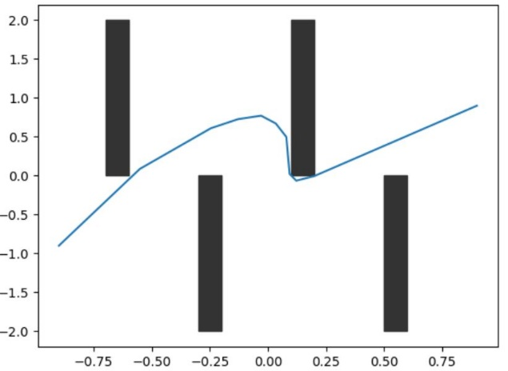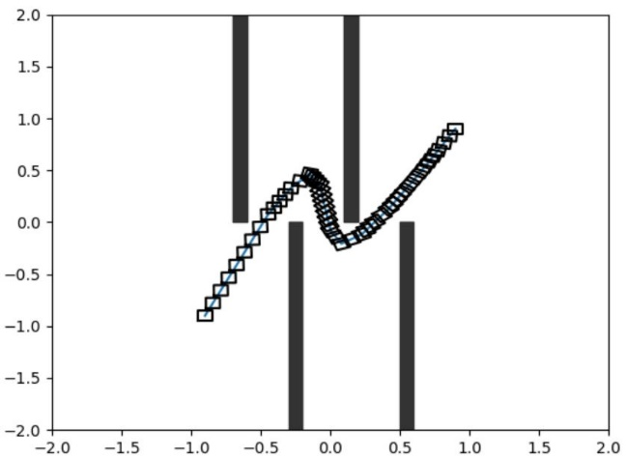

*Figure 3. Paths of Point and Square Robot performed in Environment 1*

With some possibility, the robot fails to reach the goal in time. Figure 4 shows one of these situations.

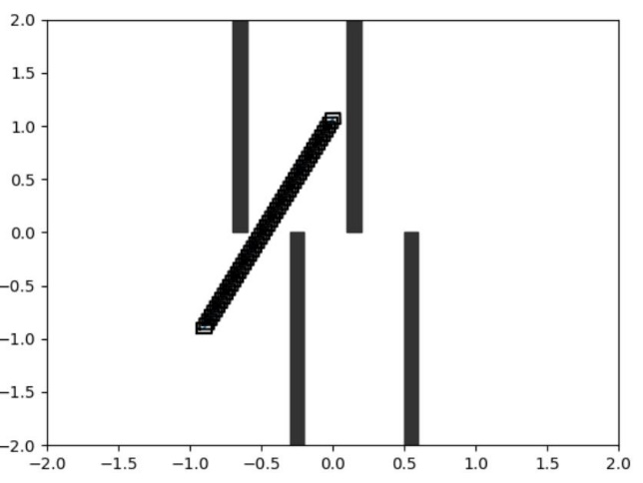

*Figure 4. Failure of the Square Robot to reach the goal in time in Environment 1*

Figure 5 shows a point robot and a square robot finding tis path using RTP planner in environment 2.

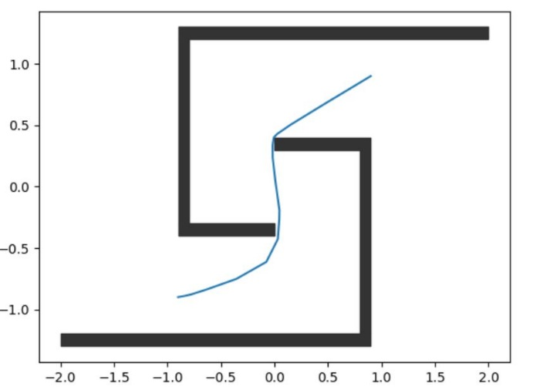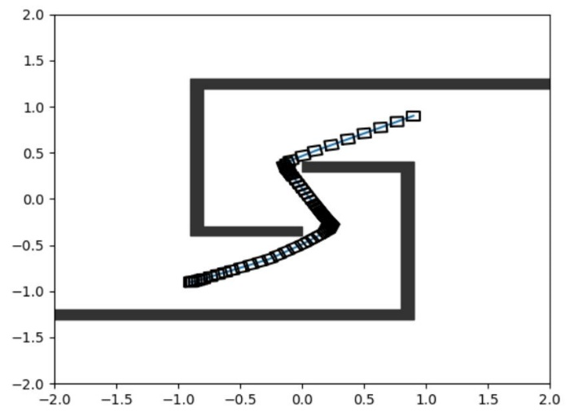

*Figure 5. Paths of Point and Square Robot performed in Environment 2*

*5. Compare and contrast the solutions of your RTP with the PRM, EST, and RRT planners from*

*exercise 3. Elaborate on the performance of your RTP. Conclusions must be presented quantitatively*

*from the benchmark data. Consider the following metrics: computation time, path length, and the*

*number of states sampled (graph states).*

Compare RTP with PRM, EST and RRT planners:

- Time: RTP spends much more time than the other three planners. Figure xxx shows the computation time of each planner. RTP spends xxx time and …

- Path length: RTP path length is slightly longer than the other three others. Figure xxx shows the path length of each planner. RTP spends xxx time and …

- Graph states: RTP samples much more states than the other three planners. Figure xxx shows the graph of each planner. RTP spends xxx and …

*6. Rate the difficulty of each exercise on a scale of 1–10 (1 being trivial, 10 being impossible).*

*Give an estimate of how many hours you spent on each exercise, and detail what was the hardest part*

*of the assignment.*

Difficulty of each exercise:

Exercise 1: 7

Exercise 2: 6

Exercise 3: 6

Time spent on each exercise:

Exercise 1: 7 hours

Exercise 2: 4 hours

Exercise 3: 5.5 hours

We spent a large amount of time on reading the codes of OMPL. As to implement the RTP algorithm based on the RRT codes, we had to understand the meanings of functions and variables used in OMPL system. To do that, we searched for references in the OMPL website when meeting unknown functions and variables. I would not say that this process was extremely difficult but it did take us most time.